Picture Vocabulary Worksheet 1
Circle the correct word.
 | pram | pushchair | cradle | cot
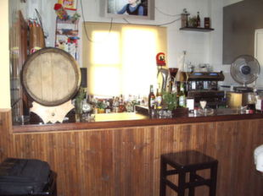 | cafe | restaurant | bar | shop
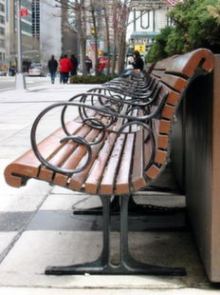 | benches | chairs | stools | banks
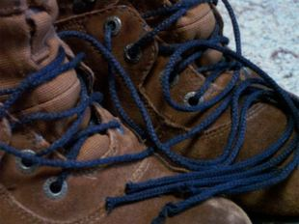 | boots | shoes | sneakers | slippers
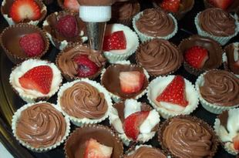 | sweets | candies | cakes | breads
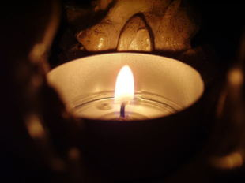 | light | lamp | candle | lights
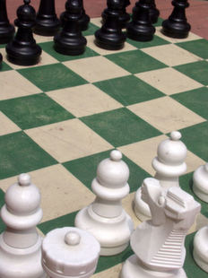 | poker | draughts | chess | backgammon
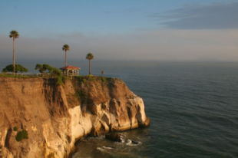 | cliff | mountain | hill | beach
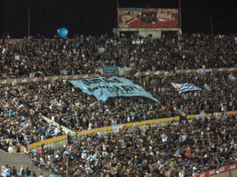 | mass | audience | public | crowd
Circle the correct word.
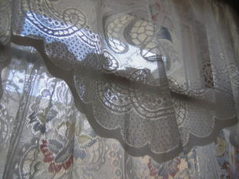 | shutters |  | blind |  | curtain | blanket
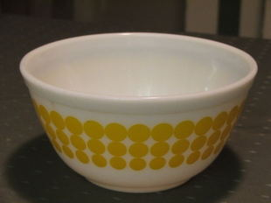 |  | cup |  | plate | dish | mug
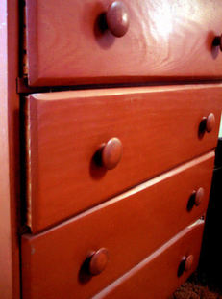 |  | drawers |  | cassettes | chest | furniture
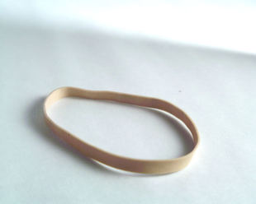 |  | elastic band |  | big band | elastic line | elastic chain
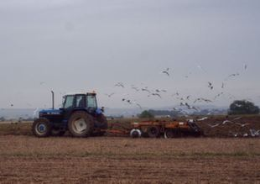 |  | truck |  | tractor | lorry | agriculture
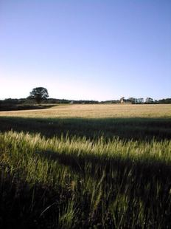 |  | region |  | camp | countryside | passage
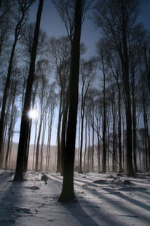 |  | woods |  | country | orchard | meadow
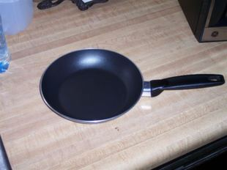 |  | plate |  | saucepan | wok | pan

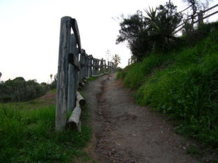 | road | lane | path | small way
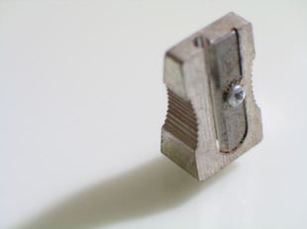 | finer | sharper | sharpener | pointer
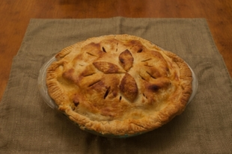 | pie | tort | sweet | cake
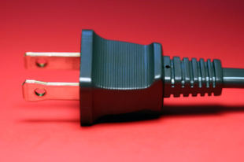 | drive | power | socket | plug
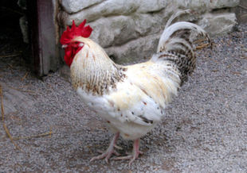 | turkey | hen | rooster | goose
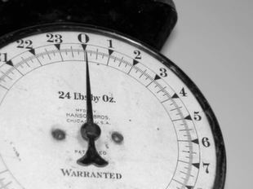 | weigher | weights | scales | balance
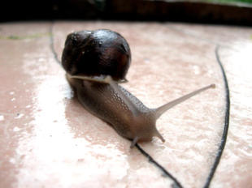 | slug | shell | snail | sheller
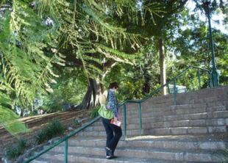 | climber | stepping | steps | escalator
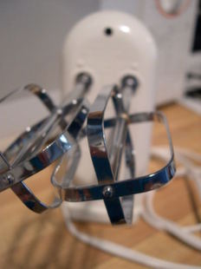 | whisk | spoons | turner | mixing
Circle the correct word.
Contact Us | Privacy Policy | Copyright Notice | Link to this Site | Site FAQ | Site Map | Advertise on the Site
© 2001-2017 esl-lounge.com

Circle the correct word.
 | Write the word: ___________
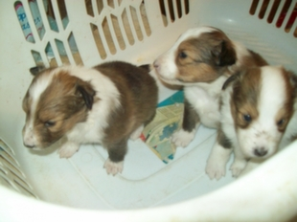 | Write the word: ___________
 | Write the word: ___________
 | Write the word: ___________
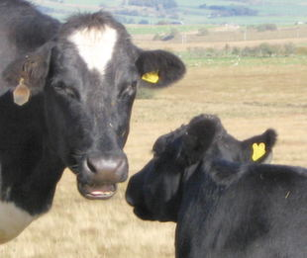 | Write the word: ___________
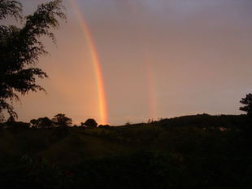 | Write the word: ___________
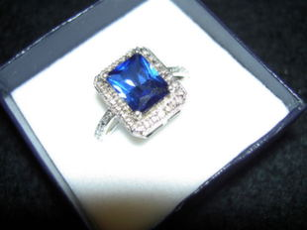 | Write the word: ___________
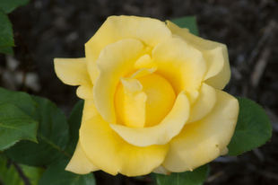 | Write the word: ___________
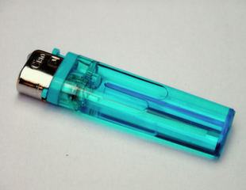 |  | a cigarette ______
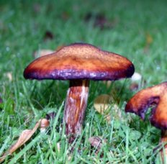 |  | a ______
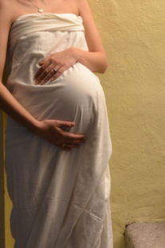 |  | the woman is ______
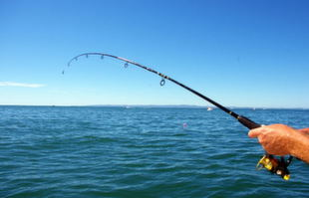 |  | a fishing ______
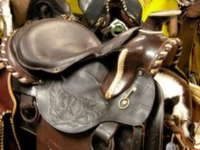 |  | a horse ______
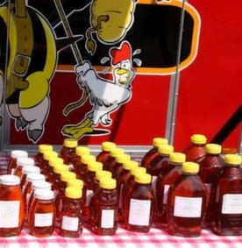 |  | ______ from a bee
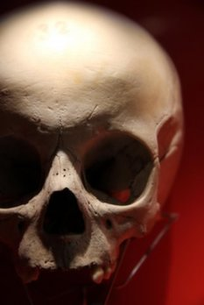 |  | a ______
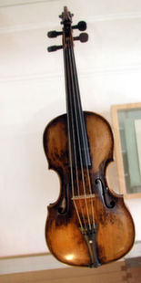 |  | a ______
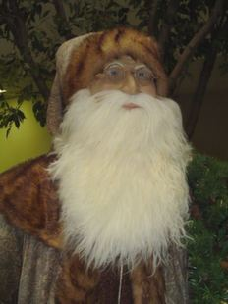 | a big white ______
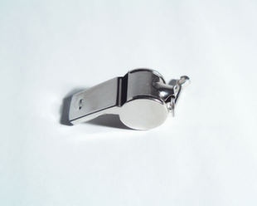 | a ______
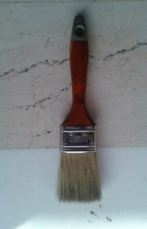 | a paint ______
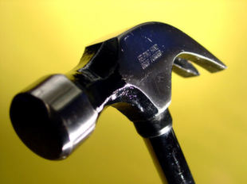 | a ______
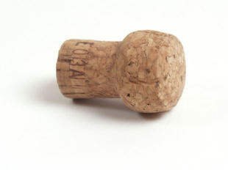 | a ______
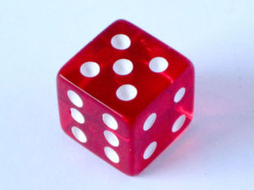 | a ______
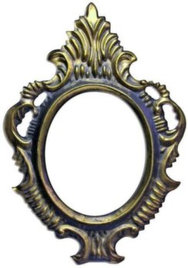 | the ______ for a picture
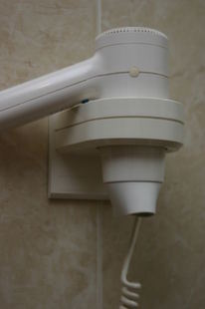  Picture Vocabulary Worksheet 3  Circle the correct word. | a hair ______
  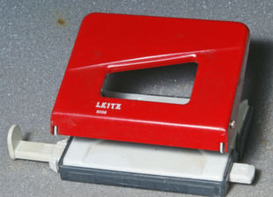 | hole punch | stapler | shredder | holer
  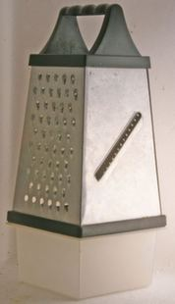 grater | blender | slicer | grater | masher
  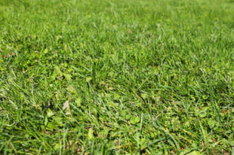 | field | meadow | lawn | countryside
  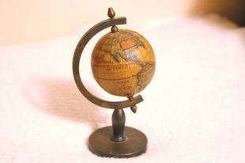globe | globe | map | world | hemisphere
  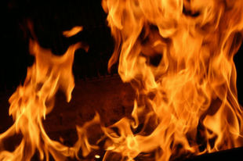 | cinders | fires | bonfire | flames
   | drawers | cabinet | cassette | furniture
   | mug | plate | dish | saucer
  Picture Vocabulary Worksheet 5 - British and American  Circle the correct word.  Picture Vocabulary Worksheet 1  Write the correct word(s) into the space. | ravine | mountain | cliff | caves
    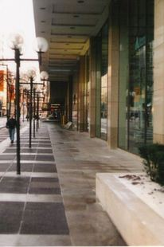pavement | British English: ______ / American English: sidewalk
    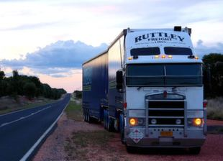 | British English: lorry / American English: ______
    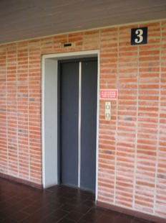 | British English: lift / American English: ______
    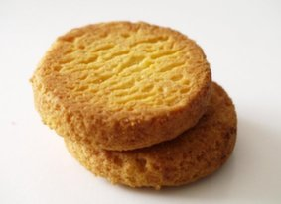 | British English: ______ / American English: cookie
    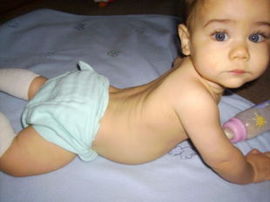 | British English: nappy / American English: ______
    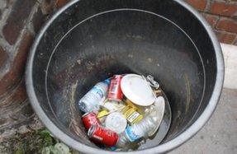 | British English: ______ / American English: garbage
    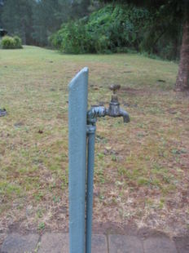column | British English: tap / American English: ______
    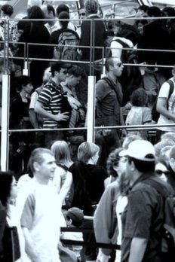 | British English: ______ / of people American English: line of people
    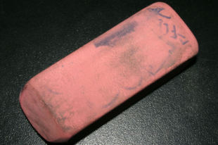 | British English: ______ / American English: eraser  rubber
    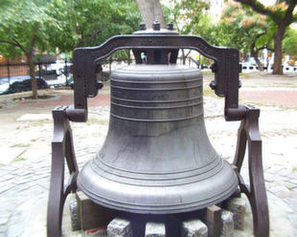 | Write the word: ___________
    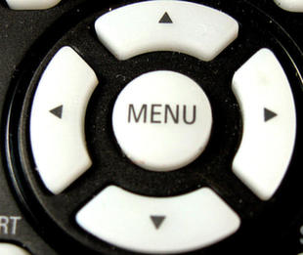 | Write the word: ___________
     | Write the word: ___________
    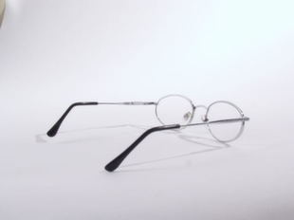 | Write the word: ___________
    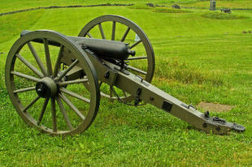 | Write the word: ___________
     | Write the word: ___________
    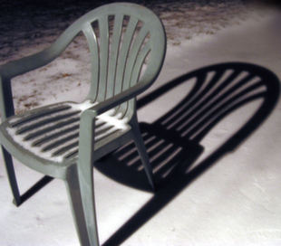 | Write the word: ___________
    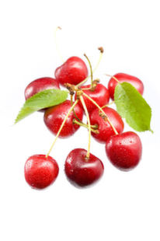 | Write the word: ___________
Circle the correct word.

Personality Vocabulary Wordsearch

Word list:

Mean | Generous | Selfish
Talkative | Shy | Outgoing
Arrogant | Modest | Sympathetic
Friendly | Argumentative | Placid
Sensitive | Cold | Sociable

D | F | R | M | J | Y | F | T | S | W | E | D | F | R | T
G | E | T | E | J | U | H | Y | T | S | E | D | O | M | C
R | V | T | A | J | F | R | I | E | N | D | L | Y | H | T
S | I | W | N | V | F | R | S | M | J | U | I | K | O | T
A | T | H | D | H | G | I | E | S | D | F | G | H | J | N
C | A | Y | E | Y | P | I | L | B | H | U | J | Y | T | A
F | T | T | W | G | J | K | F | X | S | D | F | T | G | G
G | N | R | S | F | G | N | I | O | G | T | U | O | S | O
H | E | F | P | D | Y | H | S | G | T | Y | P | W | E | R
J | M | G | L | C | F | R | H | N | H | Y | J | E | N | R
Y | U | T | A | L | K | A | T | I | V | E | O | L | S | A
T | G | H | C | C | B | G | H | N | J | M | K | B | I | U
R | R | J | I | S | U | O | R | E | N | E | G | A | T | Y
E | A | U | D | E | X | D | R | T | Y | H | G | I | I | T
E | Y | K | K | R | C | O | L | D | L | O | P | C | V | E
E | Y | Y | I | F | Q | W | S | D | E | R | F | O | E | R
G | R | T | O | V | V | F | E | S | W | A | Q | S | J | H
F | M | S | Y | M | P | A | T | H | E | T | I | C | K | I

Find The Phoneme
Look carefully at the phoneme for each question. Which of the four following words contains that phoneme?
1. 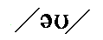 touch - eight - hope - pool
2. 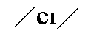 bag - take - party - phone
3.  father - mother - sister - brother
4.  path - far - cat - seven
5.  fear - pear - each - see
6.  meat - big - its - end
7. 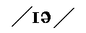 clean - feet - ear - head
8.  first - Terry - pear - seen

1. touch - eight - hope - pool
2. bag - take - party - phone
3. father - mother - sister - brother
4. path - far - cat - seven
5. fear - pear - each - see
6. meat - big - its - end
7. clean - feet - ear - head
8. first - Terry - pear - seen

Find The Phoneme
Look carefully at the phoneme for each question. Which of the four following words contains that phoneme?
9. 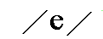 peas - pear - pet - play
10.  hate - fail - word - island
11.  should - shoe - shut - ship
12. 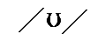 foot - under - shut - box
13.  know - go - apple - top
14. 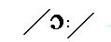 would - flower - or - wake
15.  grow - York - shout - bath
16. 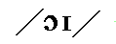 girl - boy - man - dog

9. peas - pear - pet - play
10. hate - fail - word - island
11. should - shoe - shut - ship
12. foot - under - shut - box
13. know - go - apple - top
14. would - flower - or - wake
15. grow - York - shout - bath
16. girl - boy - man - dog

17. 
a. month
b. mouth
c. math
d. test
18. 
a. bean
b. buy
c. pine
d. pill
19. 
a. poor
b. took
c. pure
d. food
20. 
a. the
b. feed
c. this
d. then
21.
a. call
b. park
c. one
d. cap
22.
a. our
b. lime
c. crack
d. game
23.
a. stall
b. floor
c. ant
d. out
24.
a. fear
b. bar
c. beer
d. bear

17.
a. month
b. mouth
c. math
d. test
18.
a. bean
b. buy
c. pine
d. pill
19.
a. poor
b. took
c. pure
d. food
20.
a. the
b. feed
c. this
d. then
21.
a. call
b. park
c. one
d. cap
22.
a. our
b. lime
c. crack
d. game
23.
a. stall
b. floor
c. ant
d. out
24.
a. fear
b. bar
c. beer
d. bear

25.
a. leer
b. learn
c. law
d. tower
26.
a. see
b. saw
c. sour
d. Sir
27.
a. weird
b. war
c. word
d. car
28.
a. step
b. stop
c. steep
d. stick
29.
a. fin
b. Tom
c. time
d. Tim
30.
a. fowl
b. fall
c. foal
d. fell
31.
a. wood
b. pot
c. moon
d. lock
32.
a. smooth
b. took
c. lock
d. bus

25.
a. leer
b. learn
c. law
d. tower
26.
a. see
b. saw
c. sour
d. Sir
27.
a. weird
b. war
c. word
d. car
28.
a. step
b. stop
c. steep
d. stick
29.
a. fin
b. Tom
c. time
d. Tim
30.
a. fowl
b. fall
c. foal
d. fell
31.
a. wood
b. pot
c. moon
d. lock
32.
a. smooth
b. took
c. lock
d. bus

33.
a. car
b. pat
c. now
d. fox
34.
a. saw
b. month
c. as
d. sock
35.
a. town
b. country
c. city
d. village
36.
a. tea
b. toe
c. toy
d. tie
37.
a. dab
b. dub
c. Deb
d. daub
38.
a. pig
b. peg
c. poor
d. bag
39.
a. pea
b. earn
c. ten
d. father
40.
a. cot
b. cut
c. cat
d. coat

33.
a. car
b. pat
c. now
d. fox
34.
a. saw
b. month
c. as
d. sock
35.
a. town
b. country
c. city
d. village
36.
a. tea
b. toe
c. toy
d. tie
37.
a. dab
b. dub
c. Deb
d. daub
38.
a. pig
b. peg
c. poor
d. bag
39.
a. pea
b. earn
c. ten
d. father
40.
a. cot
b. cut
c. cat
d. coat

41.
a. path
b. failure
c. pylon
d. fear
42.
a. tar
b. poke
c. pack
d. all
43.
a. mouse
b. mat
c. hawk
d. father
44.
a. where
b. who
c. what
d. which
45.
a. fair
b. far
c. fear
d. fur
46.
a. moan
b. mean
c. main
d. men
47.
a. sheep
b. fur
c. far
d. shed
48.
a. hut
b. hit
c. hand
d. hen

41.
a. path
b. failure
c. pylon
d. fear
42.
a. tar
b. poke
c. pack
d. all
43.
a. mouse
b. mat
c. hawk
d. father
44.
a. where
b. who
c. what
d. which
45.
a. fair
b. far
c. fear
d. fur
46.
a. moan
b. mean
c. main
d. men
47.
a. sheep
b. fur
c. far
d. shed
48.
a. hut
b. hit
c. hand
d. hen

1.
a. row
b. rye
c. rinse
d. rat
2.
a. sow
b. saw
c. set
d. sigh
3.
a. took
b. soon
c. should
d. top
4.
a. wood
b. too
c. cut
d. fuss
5.
a. cap
b. like
c. stop
d. mouse
6.
a. ouch!
b. or
c. lift
d. up
7.
a. August
b. July
c. mouth
d. month
8.
a. con
b. coin
c. can
d. can't

1.
a. row
b. rye
c. rinse
d. rat
2.
a. sow
b. saw
c. set
d. sigh
3.
a. took
b. soon
c. should
d. top
4.
a. wood
b. too
c. cut
d. fuss
5.
a. cap
b. like
c. stop
d. mouse
6.
a. ouch!
b. or
c. lift
d. up
7.
a. August
b. July
c. mouth
d. month
8.
a. con
b. coin
1. cousin - pure - university - put
2. me - I - you - the
3. sure - do - took - due
4.  think - inch - shush! - ache
5. teen - pen - said - fill
6. 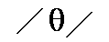 the - mother - think - church
7.  chimpanzee - shower - father - fox
8.  yes - Japan - Germany - play

1. cousin - pure - university - put
2. me - I - you - the
3. sure - do - took - due
4. think - inch - shush! - ache
5. teen - pen - said - fill
6. the - mother - think - church
7. chimpanzee - shower - father - fox
8. yes - Japan - Germany - play

1.
a. chip
b. gate
c. chic
d. Gemini
2. 
a. honest
b. hour
c. happen
d. honor
3. 
a. dip
b. genius
c. gap
d. China
4. 
a. teeth
b. father
c. think
d. thought
5.
a. mother
b. this
c. path
d. the
6. 
a. shop
b. ceiling
c. vision
d. passion
7.
a. candles
b. cushion
c. mishap
d. just
8.
a. jest
b. jar
c. yeast
d. play

1.
a. chip
b. gate
c. chic
d. Gemini
2.
a. honest
b. hour
c. happen
d. honor
3.
a. dip
b. genius
c. gap
d. China
4.
a. teeth
b. father
c. think
d. thought
5.
a. mother
b. this
c. path
d. the
6.
a. shop
b. ceiling
c. vision
d. passion
7.
a. candles
b. cushion
c. mishap
d. just
8.
a. jest
b. jar
c. yeast
d. play

Take each square by giving the teacher three words that use that phoneme.

Take each square by giving the teacher three words that use that phoneme.


Take each square by giving the teacher three words that use that phoneme.

Work with another student and think of as many words as possible using the given phonemes. The phonemes MUST BE USED in the same order. There can be other phonemes before, in between or after these phonemes.
Example:
-
chat - chapter - chatting, etc.
1.  -
2. -
3.  -
4. -
5.  -
6. -
7. -
8. 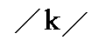 - -

ANSWER Phonetic Boggle
Here are some example answers...
1. -
club - London - love
2. -
cash - Ashley - passion
3. -
murder - defence (British English pronunciation) - under
4. -
yonder - yacht - beyond
5. -
bored - bought - abort
6. -
chips - chin - chill
7. -
ice - mice - isolate
8. - -
cloth - clock – closet

Work with another student and think of as many words as possible using the given phonemes. The phonemes MUST BE USED in the same order. There can be other phonemes before, in between or after these phonemes.
Example:
-
chat - chapter - chatting, etc.
1. - 
2. -
3. - 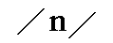
4.  -
5. -
6. -
7.  -  -
8. -

ANSWERS

Phonetic Boggle
Here are some example answers...
1. -
I'm - time - climb
2. -
other - mother - brother
3. -
town - frown - clown
4. -
pea - speed - piece
5. -
wrong - tong - long
6. -
oil - soil - Boyle
7. - -
grip - grit - Hagrid (Harry Potter character)
8. -
wax - wag - swam

